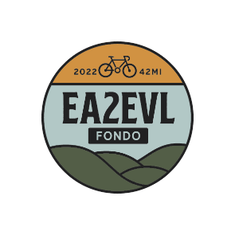
NEWS

Release Date: October 10, 2022
Contacts: Deborah H Fenn (716) 913-3274
Beth Lasky: (716) 713-4363
EA2EVL Bike Ride Raises Funds for the Erie Cattaraugus Rail Trail
Nearly 400 riders in 42-mile charity event raise $50k for rail trail
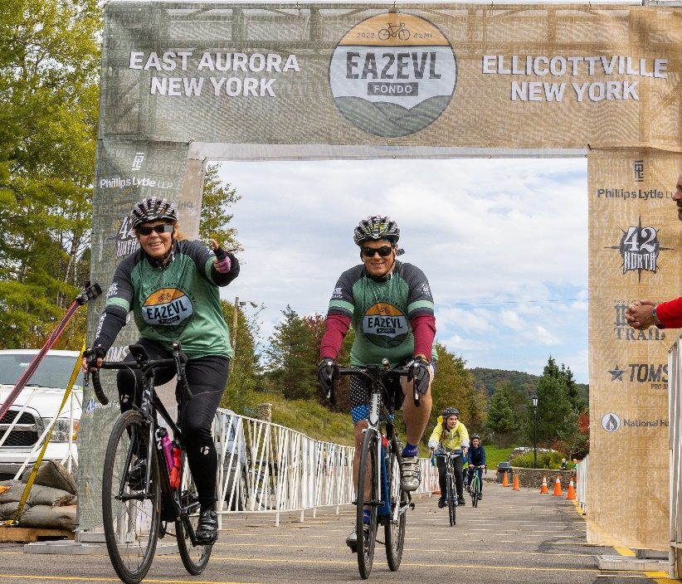
EA2EVL riders cruise to the finish line at Holiday Valley
(October 11, 2022) East Aurora, N.Y.: On Saturday, October 1, the Erie Cattaraugus Rail Trail (ECRT) hosted its second annual charity bike ride from East Aurora to Ellicottville. The EA2EVL Fondo—a non-competitive ride—grew participation 20% from the inaugural event last year, hosting close to 400 riders and netting $50,000. Those donations will be used to support ongoing efforts to build, enhance and maintain the 27-mile rail trail that runs along a former rail line from Orchard Park to Ashford, NY.
“After back-to-back successful events, we know that bikers just love this fall ride,” shared Deb Fenn, ECRT Board Chair. “Last year, we used the EA2EVL donations to remove rails and ties from the last uncleared mile of the ECRT trail. This year, we will use the funds to resurface, connect and complete sections in Orchard Park.”
EA2EVL kicked off at 42-North Brewery in East Aurora and goes up Mill Road to Route 240, where riders head south on Route 242 into the Village of Ellicottville. With water stops along the way and tech support provided by Tom’s Pro Bikes, participants enjoyed a safe, social ride, with a party at Holiday Valley. The event was sponsored by National Fuel, Tom’s Pro Bikes, 42 North Brewery and Phillips Lytle.
“Trails bring tremendous health benefits to a community—that’s one reason why I joined in this ride,” said the event’s top fundraiser, Dr. Michael Rauh of Orchard Park. “The course is picturesque and challenging, but it’s doable for all levels of riders. I was incredibly proud to wear the yellow jersey across the finish line!”
-30 -

About Erie Cattaraugus Rail Trail Inc.
Erie Cattaraugus Rail Trail, Inc. is a 501(c)(3) non-profit organization that serves as trail manager for a 27-mile recreational trail on the Buffalo Pittsburgh Railroad rail line. In 2018, ECRT, Inc. and BPRR signed a long-term rail banking agreement to allow for trail use and improvements. In Orchard Park a 2-mile section of the trail is cleared and open, but unfinished, from Ellicott Road to Jewett Holmwood Road. Additionally, a 1.7 mile Pop Warner section in Springville is open, along with another 3.5 miles of unimproved trail in East Concord. ECRT, Inc. has over 6,500 friends and community supporters. Find more information at https://www.ecattrail.org/

