November 2021 ECRT NewsFlash
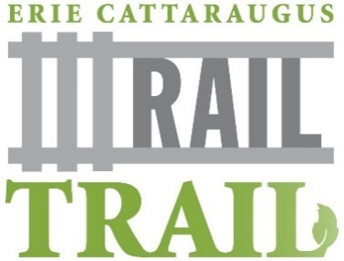
With election day behind us, the ECRT, Inc. is busy making plans to meet with newly elected town leaders from up and down the corridor. We want to build new relationships, share accurate trail facts, provide short-term plans and long-term goals, and answer their questions. ECRT, Inc. is also working hard to build our team. Our dedicated volunteers bring professional expertise and devote time, talent and treasure to the organization. Check out our updated ECRT Board list on our website, with new additions from the towns of Aurora, West Falls, Orchard Park and Boston, NY.
To learn more, contact us at: get-involved@ecattrail.org.
____________________________________________________________________________________________
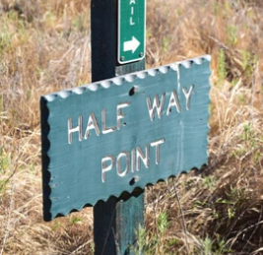
ECRT hits $60k milestone in OP campaign: We’re halfway there!
In 2020, ECRT opened an online fundraiser with the goal of raising $120,000 to improve the open section of the ECRT trail in Orchard Park between Jewett Holmwood and Ellicott roads. In November, with the help of nearly 300 generous donors—we’re half way there! We have exciting plans for 2022 and will continue to build residential and business support to improve the surface and add amenities to the trail. Learn more at https://www.ecattrail.org/optrail
Become a trail expert: Check out “Just the Facts”
Who owns the ECRT trail? Who has jurisdiction over it? What is the best way to build the trail? What does railbanking mean? What sections are open?
To get answers to these questions and more, check out the updated “Just The Facts” document on the ECRT website at www.ecattrail.org. Get up to speed and become a trail advocate. Help us share the real facts about ECRT.
Progress in Concord: Building bridges to connect communities
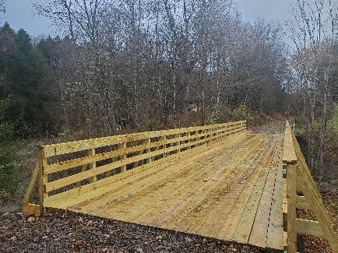
During a season of thanks, we’re thankful for our friends from the WNY Snowmobile Association of Boston. Adding onto bridge work completed in 2019, this fall, the team resurfaced two bridges on Route 240, one north and one south of Kissing Bridge. With generous support from XX local businesses, a grant from the Community Foundation of Buffalo and dedication of the Snowmobile Club, we hope to refurbish seven bridges in the next year and expand the open section of the trail in Concord. We’re so thankful for our volunteers and supporters!
___________________________________________________________________________________
EZ WAYS YOU CAN HELP:
- Tuesday, November 30 is Giving Tuesday, a global day to promote generosity and the perfect time to make your year-end contribution to ECRT at www.ecattrail.org/donate.
- This holiday season, remember to sign up for Amazon Smile and designate ECRT as your charity of choice. Each time you make a purchase, Amazon will donate 0.5% of your purchases to support your favorite charity, with no additional cost to you! Click on the icon to sign up and learn more.

